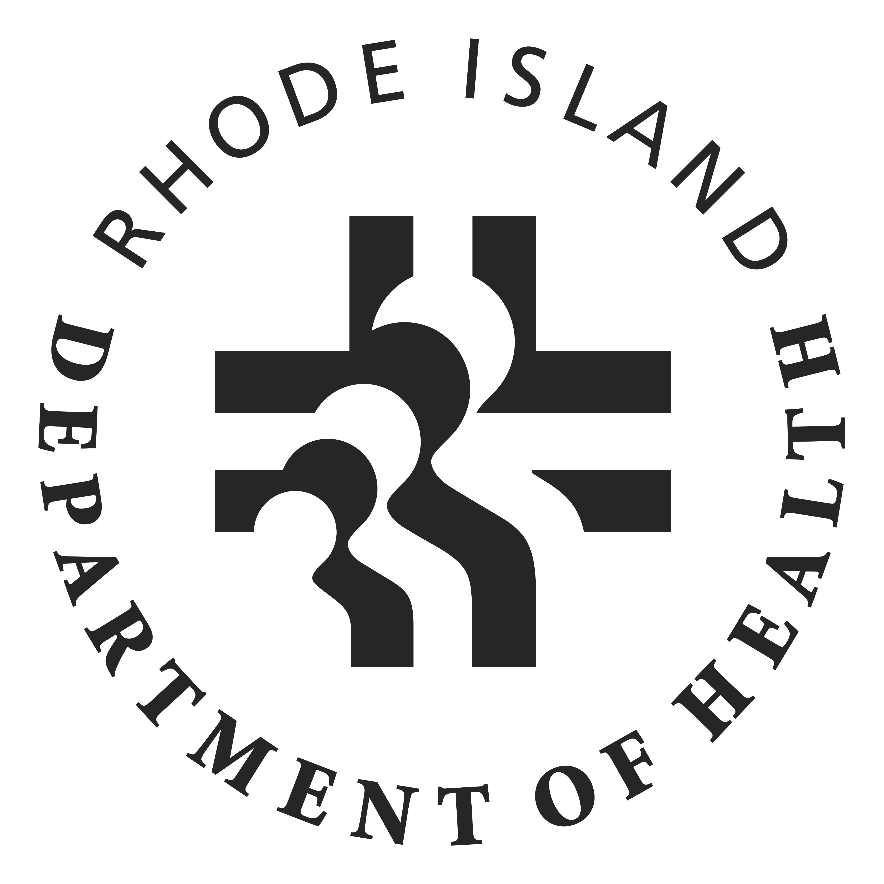

Executive Office of Health
Health Equity Institute
Refugee Health Program
2017 Mini-Grant Application Form

Instructions: Please read through each of the following sections and complete either in the given form or preferably, in another word document. Please refer to the review criteria document to understand how the application will be reviewed. The application form should not be longer than 3 type written pages.

SECTION I: AGENCY CAPACITY

Briefly describe your organization and your organization’s experience in providing services, support, and engagement with refugee populations in RI. Describe your organization’s previous experience in promoting health and wellness focused on addressing health disparities and achieving health equity.

SECTON II: SCOPE OF WORK & SUSTAINABILITY

Provide a summary of the proposed project and project goals. Discuss plans on how the project and/or related activities will continue after funding is over. If you have previously received funding from the former RI Office of Minority Health to carry out this or a similar program, please describe your success in achieving the outlined aims and goals. What were other sources of funding (if any)?
SECTION III: PERSONNEL & TIMELINE

Describe who will work on the project and their past experience working in this area. Please detail your organization’s plan as it relates to this initiative along with a detailed timeline.

SECTION VI: BUDGET NARRATIVE
Please briefly describe your proposed budget expenses for this project and complete the budget form included in this project. The maximum allowable budget for this project is $4,500.00. Note: Due to federal budget restrictions, mini-grant funds may not be used for the purchase of food or beverages.

If you have any questions or concerns, please contact Neha Patel at 222-5940 or Neha.Patel@health.ri.gov

Return via email (preferred), fax, or in person no later than May 5, 2017, 3:00 pm to:
Neha Patel
Refugee Health Coordinator

RI Department of Health, Rm. 303
Telephone: 401-222-5940
Fax: 401-222-1442
Email: Neha.Patel@health.ri.gov

