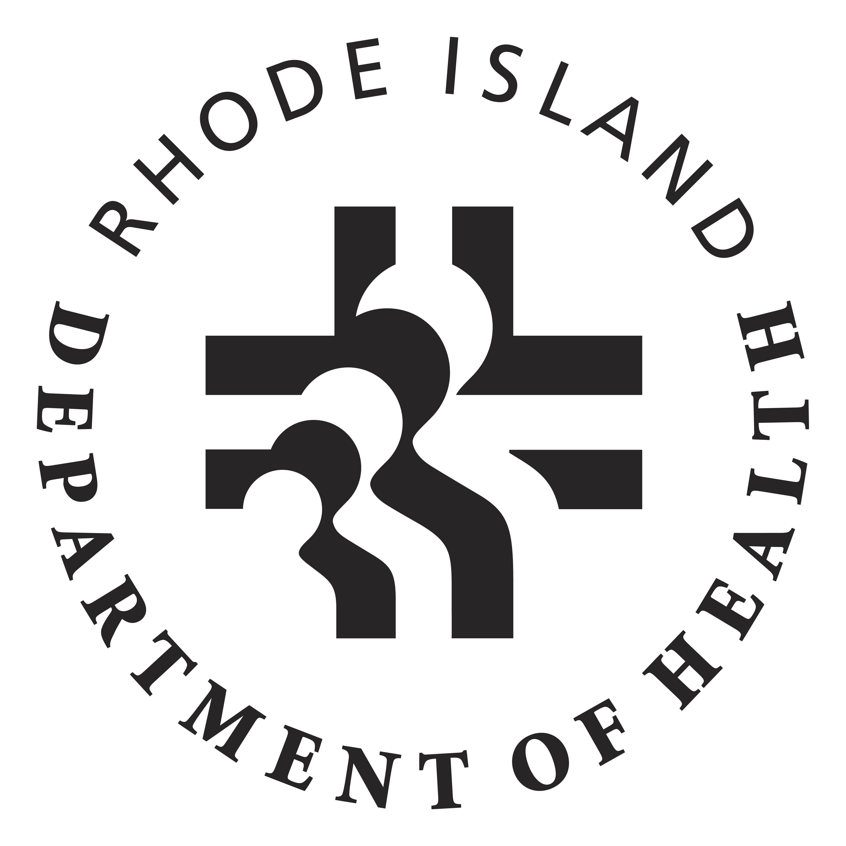
Rhode Island Department of Health
Drug Overdose Prevention Program
Mini-Grant Application Form

Instructions: Please complete Sections I – V of the mini-grant application using Times New Roman, size 12 font. Applications must be received by Friday, March 17, 2017 at 5 p.m. via email to Jennifer Koziol: Jennifer.Koziol@health.ri.gov. Incomplete applications will not be accepted.

SECTION I: AGENCY CAPACITY (10 points)
Briefly describe your organization’s experience in providing services and support to populations affected by drug overdose and in conducting overdose prevention work. Use of bullet points is acceptable.
250 words maximum

SECTON II: SCOPE OF WORK (20 points)
Provide a detailed summary of the proposed project. Describe how this project addresses findings from the MODE Team Reports (attached). Use of bullet points is acceptable.
300 words maximum

SECTION III: PROJECTED OUTCOMES AND EVALUATION (10 points)
What is/are the short-term outcome(s) of the project (i.e., products developed, number of people reached)? How will you measure progress? What are the intended long-term outcomes of your project (i.e., behavior change)? Add or delete rows as necessary.

Project Outcome(s) | How will you measure outcome success?
1. | 1.
2. | 2.
3. | 3.
Intended long-term outcome(s) of the project:

1.

2.

SECTION IV: PERSONNEL & WORK PLAN (10 points)
List the staff that will be involved with the project and briefly describe their relevant experience. Add or delete rows as necessary.

Name | Title | Experience
1.

2.

Provide project work plan. All grant activities must be completed within three months or less of purchase order receipt. The exact start date will be dependent on state purchasing procedures. Use April 15, 2017 as an estimated “Begin Date” with the understanding that processing delays may occur. Add or delete rows as necessary.

Activities | Staff Responsible | Begin Date | End Date
1. |  | April 15, 2017
2.
3.
4.

SECTION V: BUDGET NARRATIVE (10 points)
Please list and briefly describe your proposed budget. The maximum allowable budget for this project is $4,900.00. Note: Due to federal budget restrictions, mini-grant funds may not be used for the purchase of food or beverages. Grant funds cannot be used for purchasing naloxone, implementing or expanding drug “take back” programs, or directly funding or expanding substance abuse treatment programs. Add or delete rows as necessary.

Item/Staff | Amount | Justification
1. | $
2 | $
3. | $
4 | $
5. | $
6. | $
7. | $
8. | $
9. | $
10. | $
11. | $
12. | $
13. | $
14. | $
15. | $

If you have any questions, please contact Jennifer Koziol, MPH:
(401) 222-4964 | Jennifer.Koziol@health.ri.gov

